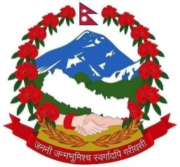
Government of Nepal
Ministry of Health & Population
Department of Health Services
Management Division
(2078-79)

Annual Report on Grievances Received and Resolved via the Web based
Grievance Handling and Redressal Mechanism (GHRM)

Yearly Report from 2021/07/16 to 2022/07/16
S.No Receiving Office Details
- Grievances received within the report period Numbers
Written Letter 16
- Received Grievance and its Category
Free medicine is not available 0
Grievance in procurement 16
Overstock and Expired Medicine 0
Unavailability and poor status of Equipment 0
- Resolved Grievance and its Category
Grievance in Procurement 16
- Average Time Taken to Resolve the Grievance {Category wise} Days
Free medicine is not available 0
Grievance in procurement 77
Overstock and Expired Medicine 0
Unavailability and poor status of Equipment 0
Numbers
- Cumulative No of Public Users Accessing the GHRM webpage 10

Note: The average no. of days taken to resolve the grievances registered under grievance in procurement and corruption as shown is 77. As, all of the grievances received under above category were via written letter (which were resolved manually on time) but were registered and maintained in GHRM system latter on, so the average time taken to accomplish grievances under irregularities in procurement is shown high by the GHRM system.

